
UNIVERSITY OF AGRICULTURE, FAISALABAD

SUBMITTED BY

SUBMITTED TO

COURSE CODE

DEGREE

SEMESTER

REG#

Sabiqa Yaseen

MISS ANAM KHALID

CS-409

BS(DATASCIENCE)E1

3RD

2024-ag-10319

LAB MANUAL

CONDITIONAL STRUCTURE

The if….else Statement:
The if…else statement is another type of if statement. It is used to make two-way decisions. It executes one block of statement(s) when the condition is true and the other when it is false. In any situation, one block is executed and the other is skipped. In if…else:
  - Both blocks of statement can never be executed.
  - Both blocks of statements can never be skipped.

- Flowchart:

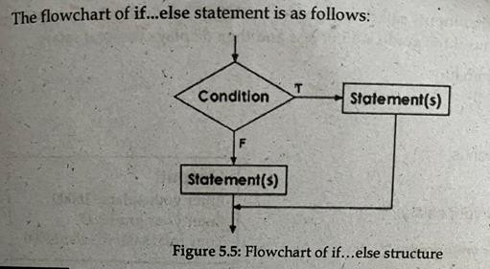

If…else…if Statement:
The if…else…if statement can be used to choose one block of statements from many blocks of statements. It is used when there are many options and only one block of statements should be executed on the basis of a condition.

Flowchart:

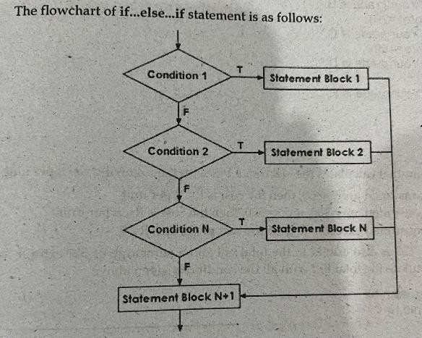

- Working of if…else…if:
The test condition of if…else…if statement with multiple alternatives are executed in a sequence until a true condition is reached. If a condition is true, the block of statements following the condition is executed. The remaining blocks are skipped. If a condition is false, the block of statements following the condition is skipped. The statement after the last else are executed if all conditions are false.

Nested if Statement:
An if statement within an if statement is called nested if statement.

Woking of Nested if:
In nested if statement,the condition of outer if is evaluated first. If it is true, the control enters in the inner if block. If the condition is false, the inner if is skipped and control directly moves to the else part of outer if. If outer if is true then the control enters in the inner if statement. The inner if evaluated according to simple if statement.

- Flowchart:

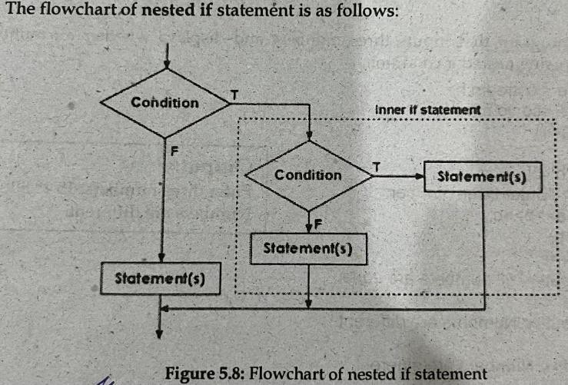

PROGRAM#1
Write a program to find the largest of three number using nested if.
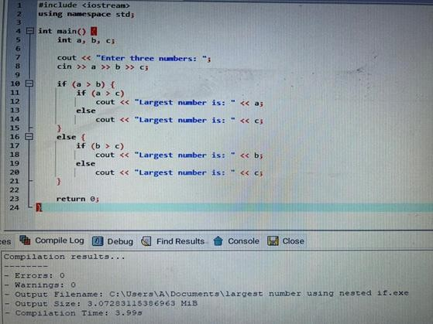

Execution:
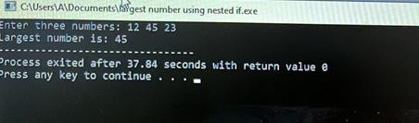

PROGRAM#2
Write a program to check whether a number is even or odd using if-else.

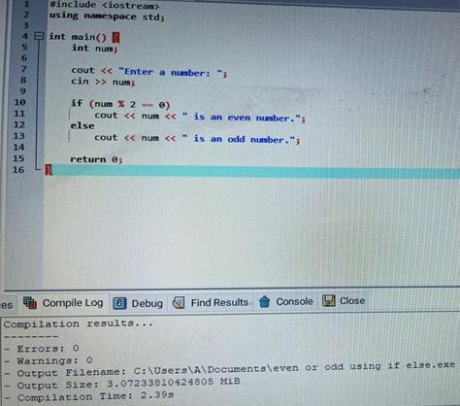

Execution:
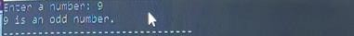

PROGRAM#3
Write a program for grade calculation based on marks using if-else-if ladder.

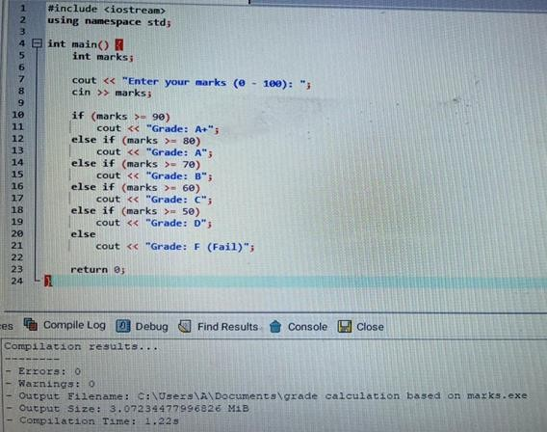

Execution:

PROGRAM#4
Write a program to check leap year using nested if.

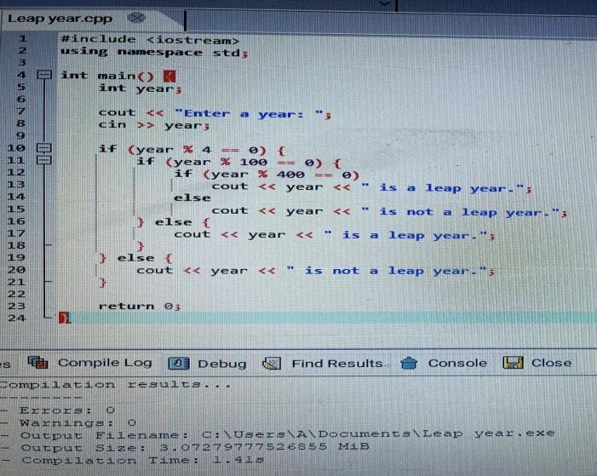

Execution:

PROGRAM#5
Write a program to check whether a character is vowel or consonant using if-else-if.
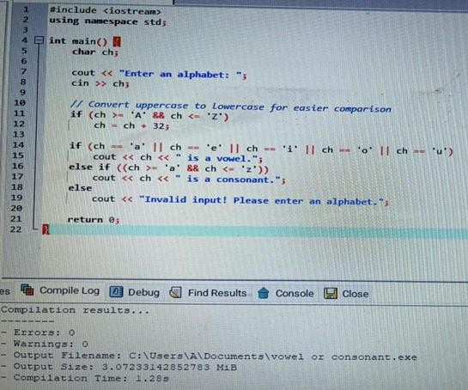

Execution:

PROGRAM#6
Write a program to check whether a number is positive, negative or zero using if-else-if.

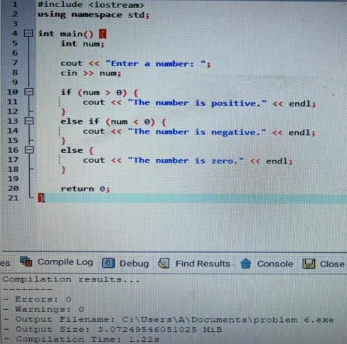

Execution:
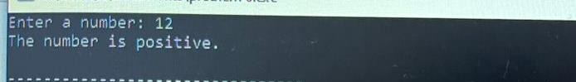

PROGRAM#7
Write a program to find the smallest of three numbers using nested if.

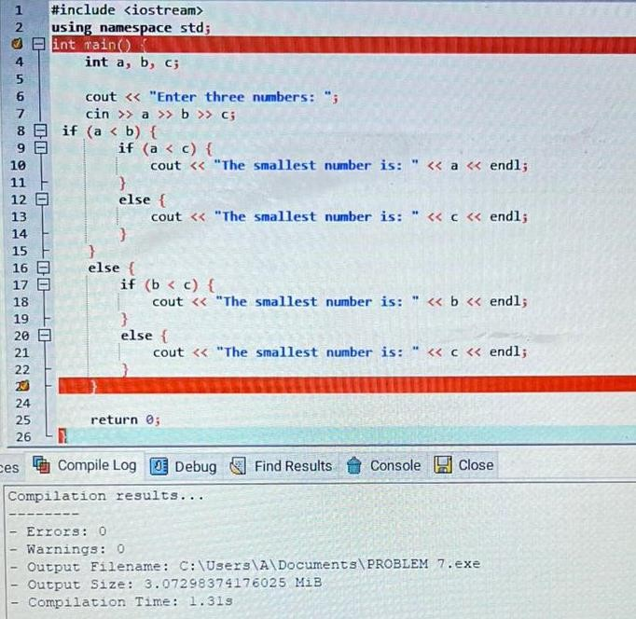

Execution:
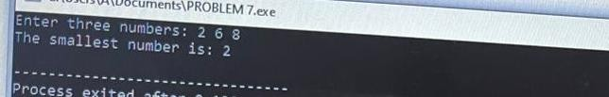

PROGRAM#8
Write a program to make a menu-driven calculator (addition, subtraction, multiplication, division).

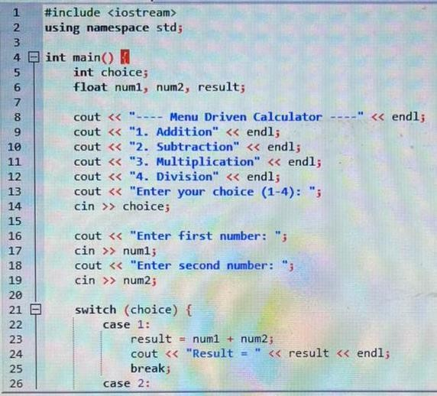

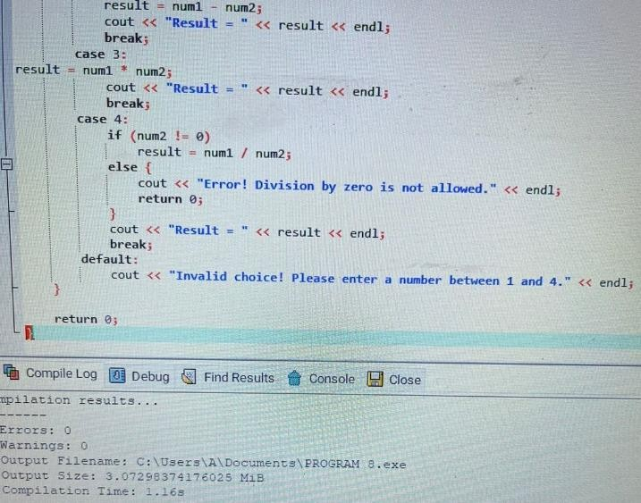

Execution:
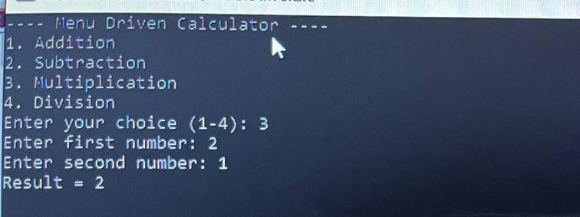

PROGRAM#9
Write a program to check whether a person is eligible to vote( age-based condition).
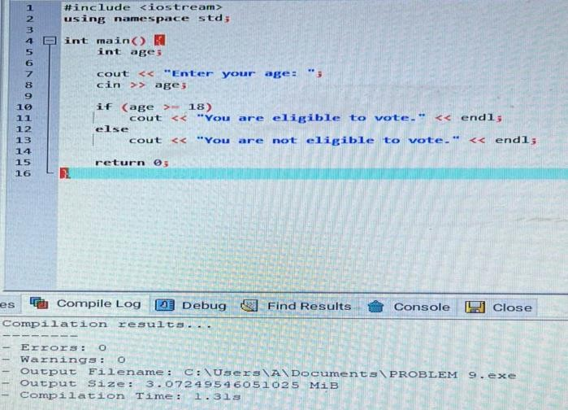

Execution:
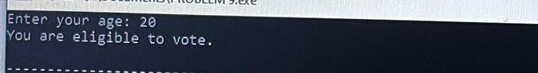

PROGRAM#10
Write a program to check whether a number is divisible by 3 and 5 using nested if.
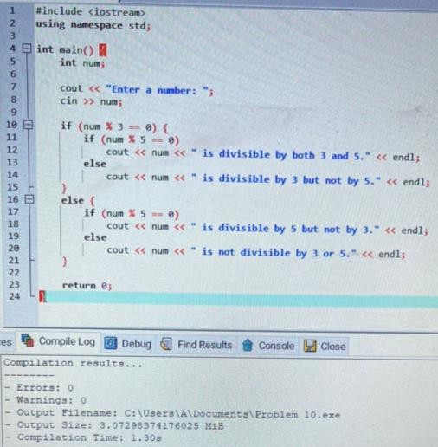

Execution:

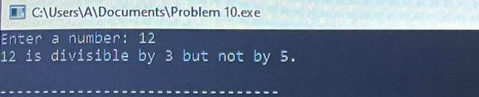

LOOPS

A type of control structure that repeats a statement or set of statements is known as
looping structure.

Loops are basically used for two purposes:
- To execute a statement or number of statements for a special number of times such as displaying the user name on screen for 10 times.
- To use a sequence of values such as displaying the numbers from 1 to 10.

There are three types of loops available in C++.
- While loop
- Do…while loop
- For loop

FOR LOOP:
For loop executes one or more statement s for a specified number of times. This loop is also called counter-controlled loop. It is the most flexible loop. That is why, it is the most frequently-used loop by the programmers.
- Working of “for”loop:
The number of iterations depend on the initialization, condition and increment/decrement. The initialization is used to initialize a variable known as loop counter or loop variable. The initialization is executed only when the control enters the loop.
The condition is evaluated after initialization. The control executes the loop body if the condition is true. Then increment/decrement part is executed that changes the value of counter variable. The control again moves to the condition.
This process continuous while the condition is true. The loop is terminated when the condition becomes false.
- Flowchart:
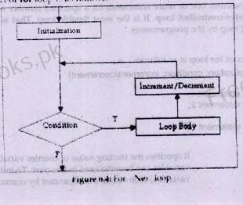

1. NESTED LOOP:
A loop within a loop is called nested loop. In nested loops, the inner loop is executed completely with each change in the value of counter variable of outer loop. The nesting can be done up to any level. The increase in level of nesting also increases the complexity of nested loop. Any loop can be used as inner loop of another loop. For example, while loop can be used as outer loop and for loop can be used as inner loop in nested loop.

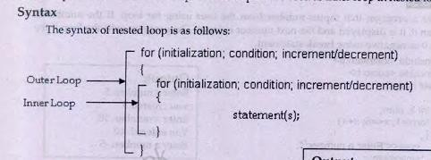

- Explanation:
The outer loop executes two times and the inner loop executes three times with each iteration of outer loop. It means that the inner loop executes six times in total. When the value of i is 1 in first iteration of outer loop, the value of j changes from 1 to 3 in three iterations of inner loop. Similarly, when the value of i is 2 in second iteration of outer loop, the value of j again changes from 1 to 3 in three iterations of inner loop.

PROGRAM#1
Write a program to print first 10 natural numbers using a for loop.

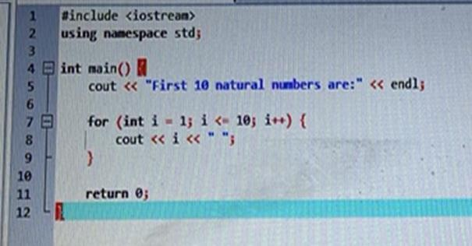

Execution:
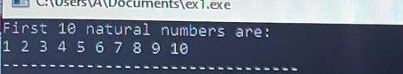

PROGRAM#2
Write a program to print multiplication table of a number using a for loop.
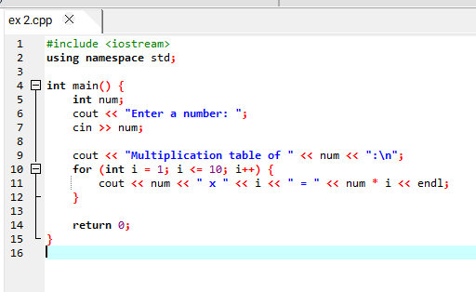
Execution:
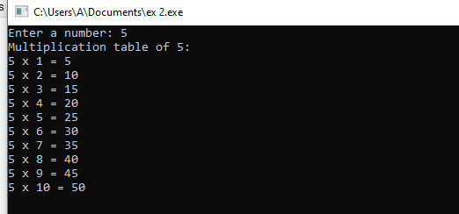

PROGRAM#3
Write a program to calculate factorial of a number using a for loop.
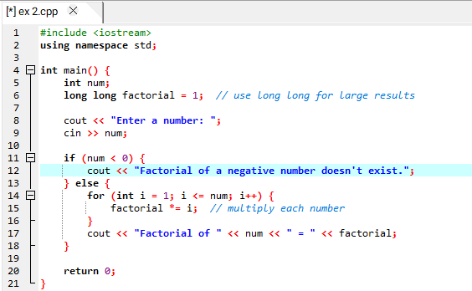
Execution:

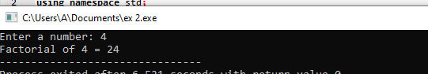

PROGRAM#4
Write a program to print Fibonacci series up to n terms using a for loop.

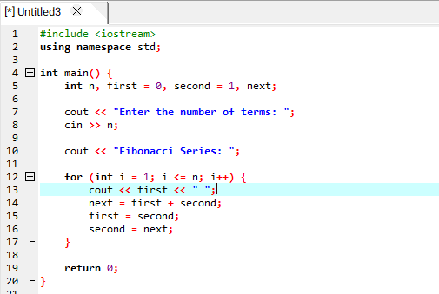
Execution:

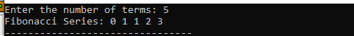

PROGRAM#5
Write a program to find the sum of digits of a number using a for loop.
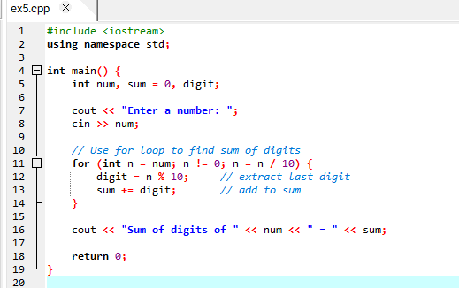
Execution:

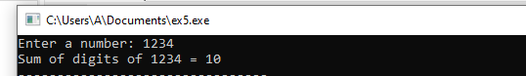

PROGRAM#6
Write a program to reverse a number using a for loop.

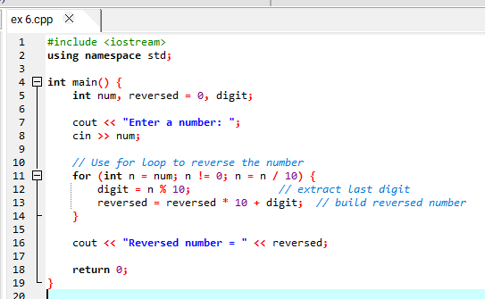
Execution:
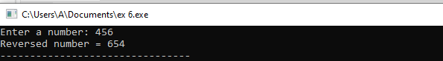

PROGRAM#7
Write a program to print a right-triangle star pattern using nested for loops.
*
**
***
****
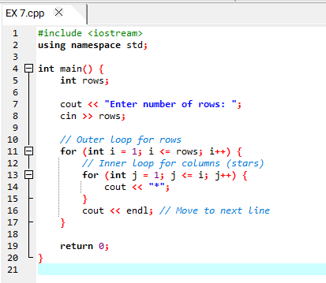
Execution:

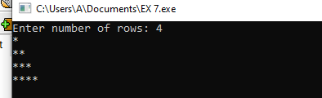

PROGRAM#8
Write a program to print a star pyramid pattern using nested for loops.
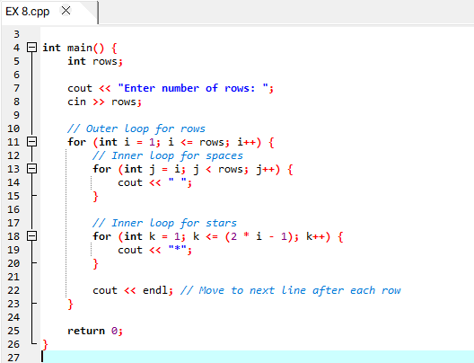

Execution:
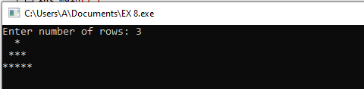

PROGRAM#9
Write a program to check whether a number is prime using a for loop.
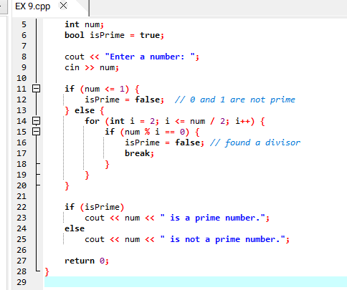
Execution:
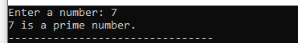

PROGRAM#10
Write a program to find the sum of first n natural numbers using a for loop.

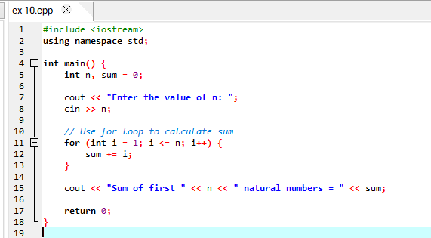

Execution:

ARRAYS

An array is a group of consecutive memory locations with same name and type. Simple variable is a single memory location with a unique name and type. But an array is a collection of different adjacent memory locations.

Advantages/ Uses of Array:
Some advantages of arrays are as follows:
- Arrays can store a large number of values with single name.
- Arrays are used to process many values easily and quickly.
- The values stored in an array can be sorted easily.
- A search process can be applied on arrays easily.

One-Dimensional Array:
A type of array in which all elements are arranged in the form of a list is known as one-dimensional array. It is also called single-dimensional array or linear list. It consist of one column and one row. The process of specifying array name, length and data type is called array declaration.
- Syntax

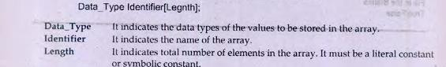

Two-Dimensional Array:
Two-dimensional array can be considered as a table that consists of rows and column. Each element in 2-D array is referred with the help of two indexes. One

index is used to indicate the row and the second index indicates the column of the element.
- Syntax
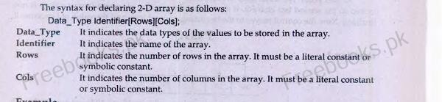

FUNCTIONS

A function is a named block of code designed to perform a specific task. It can take inputs (called parameters) and may return a result (output). Functions help in organizing and reusing code.

Importance of Functions
Functions are important because they reduce code duplication by allowing the same code to be reused. They make programs easier to read and maintain by organizing code into smaller, manageable blocks. Functions help in debugging and testing since each function can be checked separately. They promote reusability, allowing the same function to be used in different programs. Functions also support team work, as different programmers can work on different functions simultaneously. Overall, they simplify programming and make code more efficient and organized.

Advantages of Functions
- Easier to code
- Easier to modify
- Easier to maintain
- Reusability
- Less Programming Time

Types of Function in C++
- User-defined Function
- Built-in Function

User-Defined Functions
A user-defined function consists of the following:
- Function declaration
- Function definition

Function declaration
Function declaration is a model of a function. It is also called function prototype. It provides information to the compiler about the function to be used in the program. It ends with a semicolon. Function prototypes are usually placed at the beginning of the source file just before the main() function. Function declaration consists of the following parts.
- Function name
- Function return type
- Number and types of parameters
- Syntax
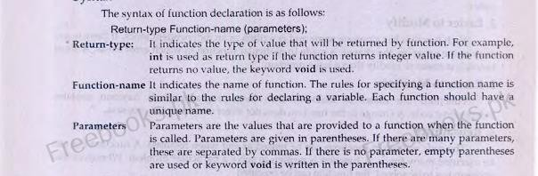

Function definition
A set of statements that explains what a function does is called function definition. The function definition can be written at the following places.
- Before main() function
- After main() function
- In a separate file

Function Call
The statement that activates a function is known as function call. A function is called its name. function name is followed by necessary parameters in parenthesis. If there are many parameters, these are separated by commas. If there is no parameters, empty parenthesis are used.
The following step is take place when a function is called:
- The control moves to the function that is called.
- All statement in the function body are executed.
- The control returns back to the calling function.
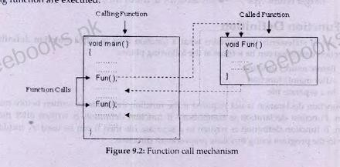
Function call mechanism

Example:
Write a program that displays a message “programming makes life interesting” on screen using function.

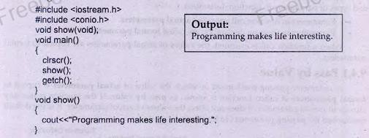

Scope of Functions
The area in which function can be accessed is known as the scope of a function.
- Local Functions
A type of function that is defined inside the body of another function is called local function. The local functions can be called within the function in which they are defined.
Example:
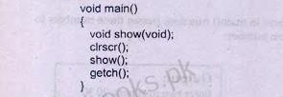

- Global Functions
A type of function that is declared outside of any function is called global function. A global function can be called from any part of the program. The global functions are typically declared at the top of the program before main() function.
Example:
The following example declares a function sum(). The function is a global function as it is declared outside any function.

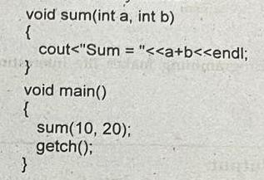

Parameters
Parameters are the values that are provided to a function when the function is called. The parameters are written in the parentheses. Multiple parameters are separated by commas. The empty parentheses are used if there is no parameter. Both variables and constants can be passed to a function as parameters. The sequence and types of parameters in function call must be similar to the sequence and types of parameters in function declaration.
Two types of parameters are as follows:
- Formal Parameters
- Actual Parameters
Passing parameters to Functions
The parameters are provided to the function when it is called. The parameters can be passed to the functions by value or by reference.

Pass by value
A parameter passing mechanism in which the value of actual parameter is copied to formal parameters of called function is known as pass by value. If the function makes any change in formal parameter, it does not affect the value of actual parameter. It is the default mechanism for passing parameters to functions.
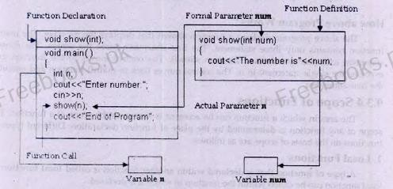

Program 9.2
Write a program that inputs two numbers in main() function, passes these numbers to a function. The function displays the maximum number.
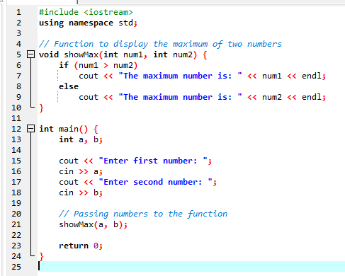
Execution
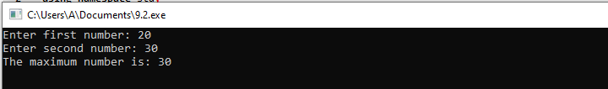

Program 9.3
Write a program that inputs a number in main function and passes the number to a function. The function displays table of that number.
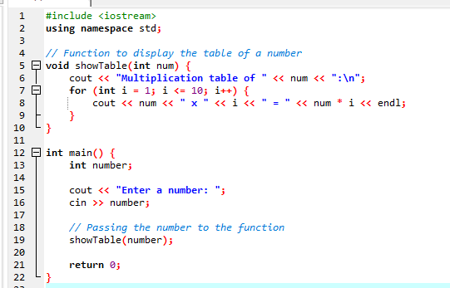

Execution

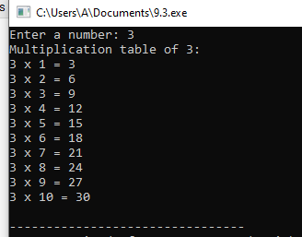

Program 9.6
Write a program to check whether a number is prime number, even number, or odd number using function.

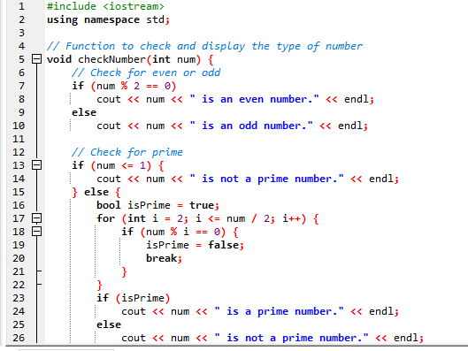
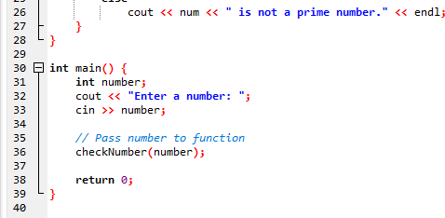
Execution
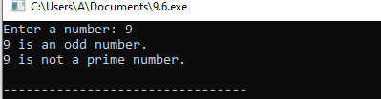

Pass by Reference
A parameter passing mechanism in which the address of actual parameter is passed to the called function is known as pass by reference. The ampersand (&) sign is used with the formal parameters to indicate pass by reference.

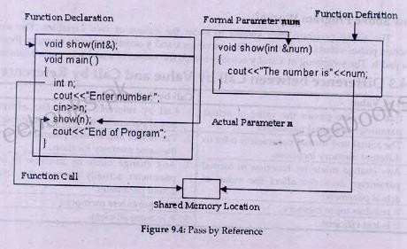

Program:
Write a program that inputs two integers in main() function and passes the integers to a function by reference. The function swaps the values. The main() function should display the values before and after swapping.
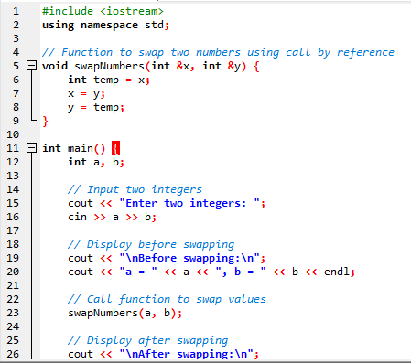
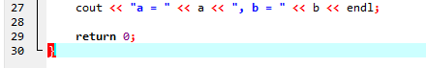

Execution:
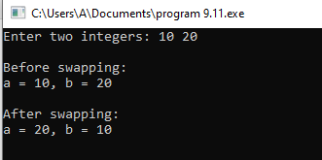

Returning Value from Function
A function can return a single value. The return type in function declaration indicates the type of value returned by a function. For example, int is used as

return type if the function returns integer value. If the function returns no value, the keyword void is used as return type. The keyword return is used to return the value back to the calling function.
When the return statement is executed in a function, the controls moves back to the calling function along with the returned value.
- Syntax:
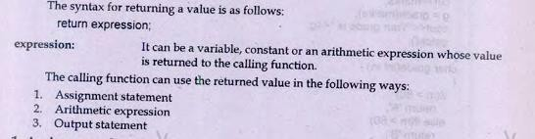

Assignment statement
The calling function can store the returned value in a variable and then use this variable in the program.
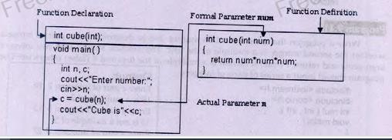

Program 9.12
Write a program that inputs marks in main function and passes these marks to a function. The function finds grade of student on the basis of the following criteria.
Grade A 80 or above marks Grade B 60 to 79 marks

Grade C 40 to 59 marks Grade D below 40 marks
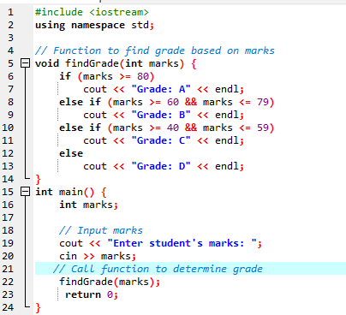

Execution:
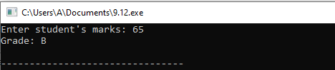

Arithmetic Expression:
The calling function can use the returned value directly in an arithmetic expression.

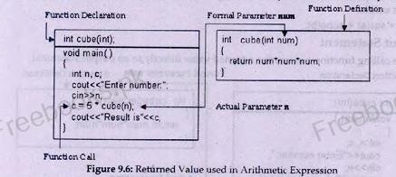

Program 9.15
Write a program that inputs two integers. It passes first integer to a function that calculates and returns its square. It passes second integer to another function that

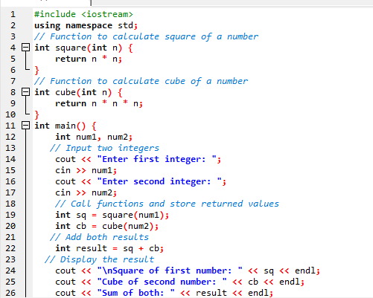
calculates and returns its cube. The main() function adds both returned values and displays the result.

Execution:
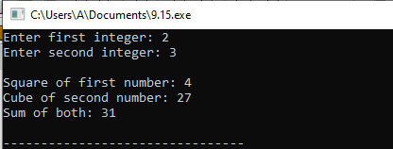

Output Statement:
The calling function can use the returned value directly in an output statement.
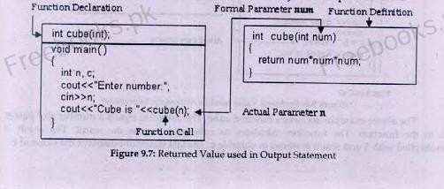

Program 9.19
Write a function called circlearea() that finds the area of a circle. It should take an argument of type float and return an argument of the same type. Write a main() function that gets a radius value from the user, calls circarea() and display the result.

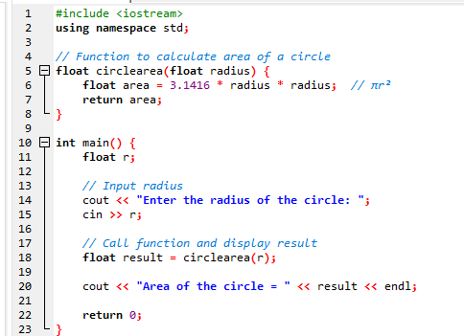

Execution:
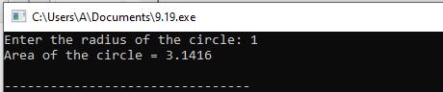

Local Variable
A variable declares inside a function is known as local variable. Local variables are also called automatic variables.

Scope of local variable
The area where a variable can be accessed is known as scope of variable. Local variable can be used only in the function in which it is declared. If a statement accesses a local variable that is not in scope, the compiler generates a syntax error.

Global Variable
A variable declared outside any function is known as global variable. Global variables can be used by all functions in the program. The values of these variables are shared among different functions. If one function changes the value of a global variable, this change is also available to other function.

Scope of Global Variable
Global variable can be used by all functions in the program. It means that these variables are globally accessed from any part of the program. Normally, global variables are declared before main function.
Program 9.20
Write a program that inputs a number in a global variable. The program calls a function that multiplies the value of global variable by 2. The main function then displays the value of global variable.
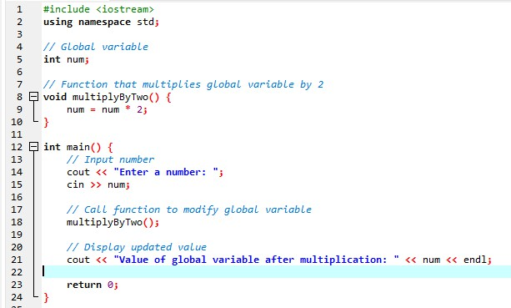

Execution:
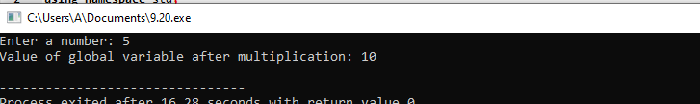

Static Variable
A local variable declared with keyword static is called static variable. The keyword static is used to increase the lifetime of local variable.

Scope of Static Variable
The scope of static variable is similar to the scope of local variable. Static variable can be used only in the function in which it is declared.
Program 9.21
Write a program that calls a function for five times using loop. The function uses a static variable initialized to 0. Each time the function is called, the value of static variable is incremented by 1 and is displayed on the screen.

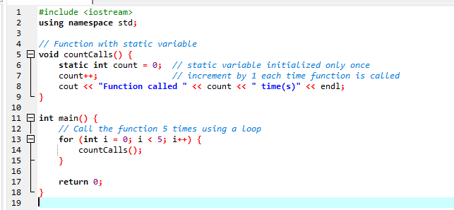

Execution:
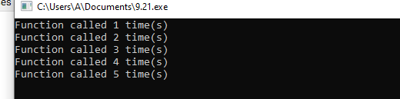

Register Variables
A variable declared with register keyword is known as register variable. The value of register variable is stored in registers instead of RAM. Registers are faster than RAM so the values stored in register can be accessed faster than the values stored in RAM.
- Syntax:

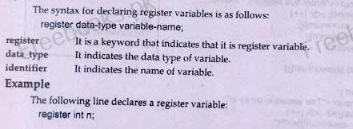

Function Overloading
The process of declaring multiple functions with same name but different parameters is called function overloading. The functions with same name must differ in one of the following ways:
  - Number of parameters
  - Type of parameter
  - Sequence of parameters
The programmer can declare the following functions to calculate average: float Average(int, int);
float Average(float, float); float Average(int, float);
- Advantages of Function Oveloading:
- Its speeds up the program execution.
- It provides readability and consistency in the programs.
- It helps in code maintenance.

Recursion
A programming technique in which a function calls itself is known as recursion. A function that calls itself is called recursive function. The recursion is a powerful technique.
- Example:
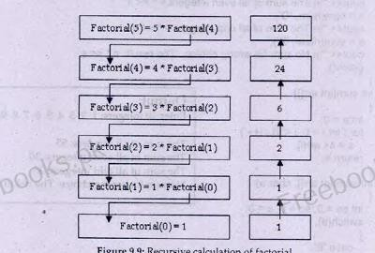

The following table provides a trace of different calls to factorial function:

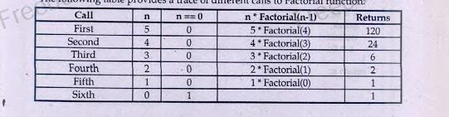

Program 9.37
Write a program that inputs two integers and calculates first number raised to the power of second number recursively.
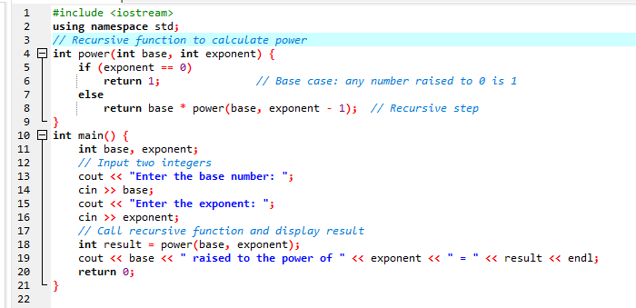

Execution:
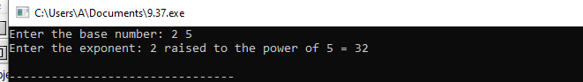

POINTERS

Memory and References
Computer memory is a collection of different consecutive memory locations. These memory locations are numbered sequentially. Each variable is created at a unique location in memory known as its address.
A variable declaration associates following three attributes to a variable:
- Variable name
- Variable type
- Variable memory address
Example:
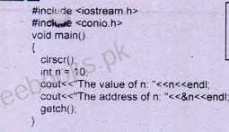

Pointers
A pointer is a variable that is used to store a memory address. The reference operator is used to access the memory address of a variable and store it in a pointer. Pointers are used in programs to access memory and manipulate data in computer memory directly.
Advantages:
- It can access the memory address directly.
- It can save memory.
- It runs faster as it does not duplicate data.

Pointer Declaration

The method of declaring a pointer is same as declaring a simple variable. An anterisk* is used to declaration that indicates that the variable is a pointer variable.
Syntax
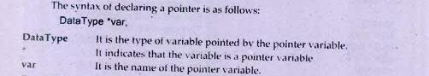

Program 11.1
Write a program that inputs a number in a integer variable. It stores the address of the variable in a pointer and then displays the value and address of the variable.
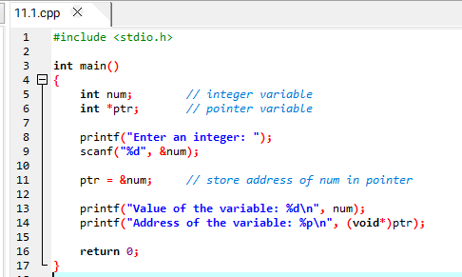

Execution:
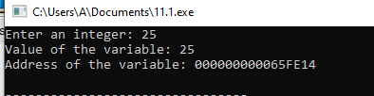

The “void” Pointer

The void pointer is a type of pointer that can store the address of any type of variable. The type of pointer variable and the type of variable it refers must be same. It restricts the use of a pointer variable to specific type of variables. A pointer variable can store the address of any type of variable if it is declared as void.
The keyword of void is used as the data type of the pointer as follows: void *p;
Example:
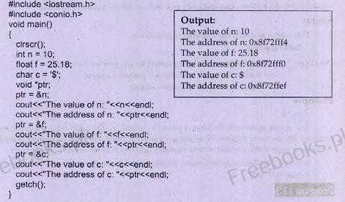

Dereference Operator
The dereference operator is used to access the value of the variable whose memory address is stored in pointer. It is denoted by asterisk *. It is also called indirection operator. It can also be used to input a value in the variable and process the data stored in the variable.

Pointer Initialization
The process of assigning a memory address to a pointer at the time of declaration is called point initialization. C++ does not initialize variables automatically.
Therefore, a pointer variable should be initialized so that it may not point to

anything invalid. The pointer can be initialize to any valid memory address. It can also be initialized to a NULL or 0 value.
Syntax:
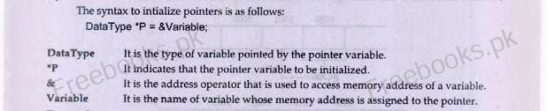

Example:
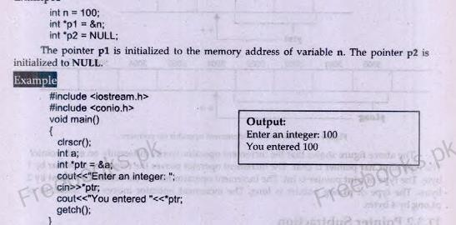

Operations on pointer
The arithmetical operation on pointer work differently than normal integer data types. Only addition and subtraction operations can be performed on pointers. The effect of both addition and subtraction depends on the size of the data type of the pointer.

Pointer Addition
The addition operation on pointer is used to move the pointer reference forward in the memory. The change of memory address referenced by the pointer depends on the data type of pointer. If the increment operator is used with an integer pointer, it will change the reference by 2 bytes. If the increment operator is used with a character pointer, it will change the reference by 1 bytes.

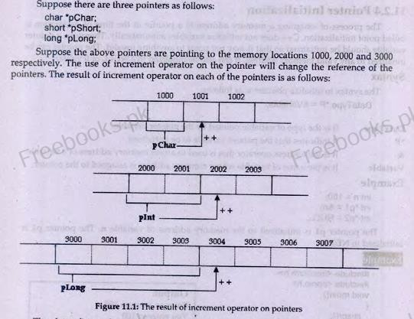

*Pointer Subtraction
The subtraction operation on pointer is used to move the pointer reference backward in the memory. The change of memory address referenced by the pointer depends on the data type of pointer. If the decrement operator is used with an integer pointer, it will change the reference by 2 bytes. If the decrement operator is used with a character pointer, it will change the reference by 1 bytes.

Pointers and Arrays
The pointers can also be used with arrays. An arrays is a collection of many elements of same type. All elements of the array are stored in consecutive memory locations. A pointer can access all elements of an array if the address of first element. The address of first element can be assigned to a pointer by assigning the name of the array to pointer. Then the pointer can access the remaining elements as they are stored consecutively in the memory.
Program 11.2
Write a program to input five integers in an array and display them using a pointer.

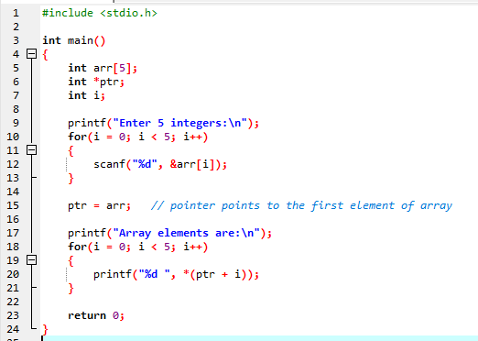

Execution:
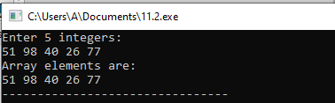

The delete Operator
The delete operator deallocates the memory and returns the allocated memory back to the free store. It takes a pointer as parameter and releases the memory referred by the pointer. The dynamically created object should be deleted when it is nor more required.
Syntax:
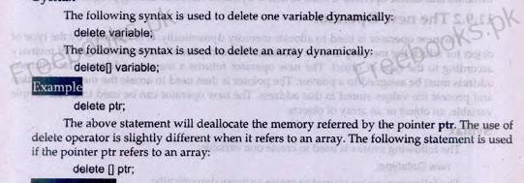

Program 11.11
Write a program that uses new operator to create an integer, inputs value in it and then displays that value.
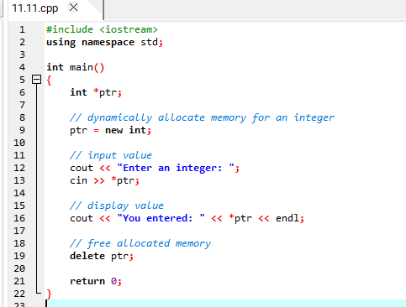

Execution:
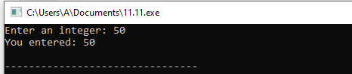

Program 11.12
Write a program that inputs length from the user and declares an array of integers of the length specified by the user. The program then inputs values in array and displays them.
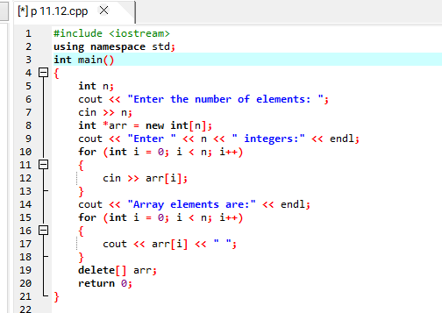

Execution:

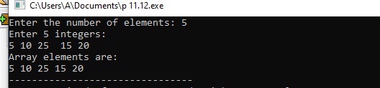

OPERATOR OVERLOADING

The process of defining additional meaning of an operator is known as operator overloading. It enables the operator to perform different operations depending on the type of operands. It also enables the operators to process the user-defined data types.
The basic arithmetic operators such as +, -,* and / normally with basic types such as int, float, and long etc. the application of these operators with basic types are already defined in the language. However, an error will occurs if these operators are used with user-defined objects. An operator can be overloaded to process the user-defined object.
Example:
c = a + b

Overloading an Operator
An operator can be overloaded by declaring a special member function in the class. The member function uses the keyword operator with the symbol of operator to be overloaded.

Syntax:
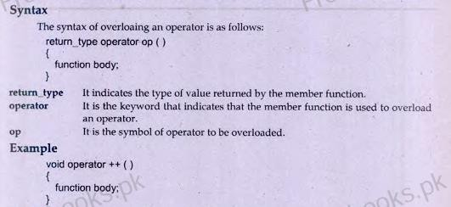

Overloading Unary Operator
A type of operator that works with single operand is called unary operator. The unary operators are overloaded to increase their capabilities.
The unary operators that can be overloaded in C++ are as follows:
+ - * ! ~ &
++ -- ( ) -> new delete

Overloading ++ Operator
The increment operator ++ is a unary operator. It works with single operand. It increases the value of operand by 1. It only works with numeric values by default. It can be overloaded to enable it to increase the values of data members of an object in the same way.
Program 14.1
Write a program that overloads increment operator to work with user-defined objects.

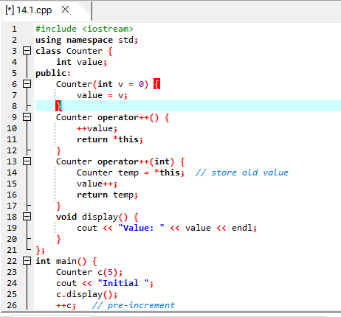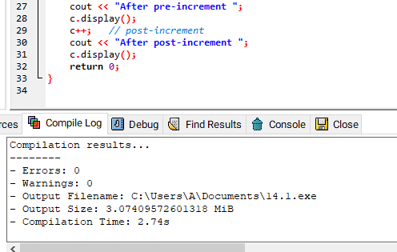

Execution:
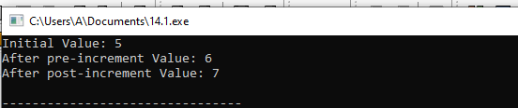

Operator Overloading with Returned Value
The increment operator can be used in assignment statement to store the incremented value in another variable. Suppose a and b are two integers. The following statement will increment the value of a by 1 and then assign the new value to b:
b = ++a

Program 14.2
Write a program that overloads increment operator to work with user-defined objects. The overloaded function should return an object after incrementing the data member.
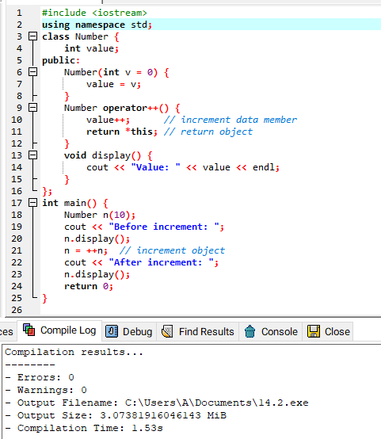

Execution:

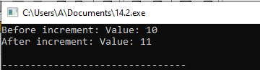

Overloading Postfix Increment Operator
The increment operator works in two notation i.e. prefix notation and postfix notation. The operator has to be overloaded separately for both notations.

Program 14.3
Write a program that overloads prefix increment operator to work with user- defined objects.
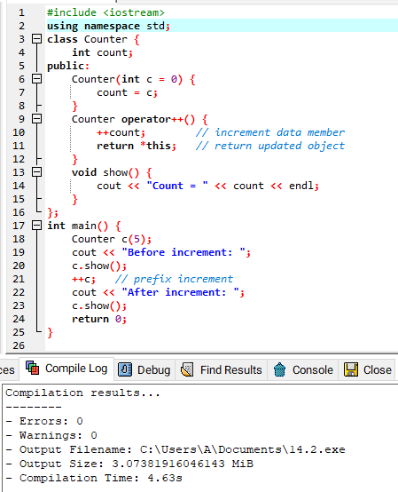

Execution:
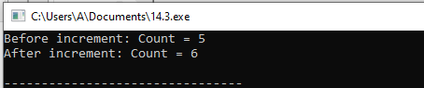

Overloading Binary Operators
A type of operator that works with two operands is called binary operator. The binary operators are overloaded to increase their capabilities.
The binary operators that can be overloaded in C++ are as follow:
+ - * / % & | ^ << >>
= = += -= /= %= &= |= ^= <<= >>=
< > < = >= && || [] ()

Arithmetic Operators
The binary arithmetic operators such as + , - ,*, / are binary operators. They work with two operands. These operators can be overloaded to enable them to work with user-defined objects in the same way as they work with basic types such as int, long and float etc.
Program 14.4
Write a program that overloads binary addition operator +.

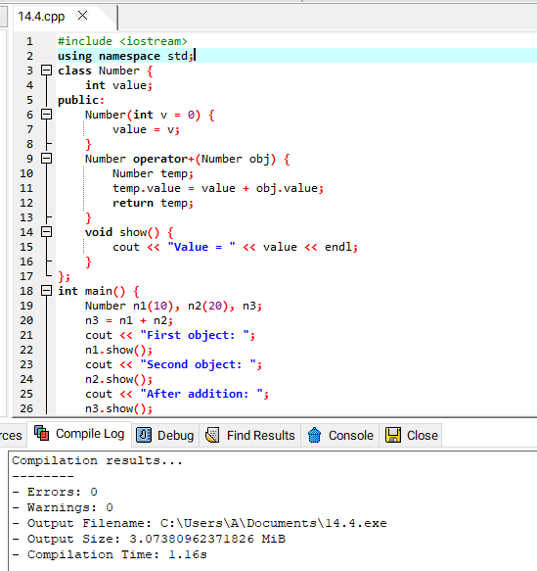

Execution:
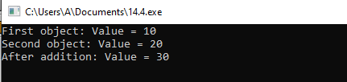

Overloading Comparison Operator
The comparison operators are binary operators. These operators are frequently used to compare the values of basic data types. Suppose a and b are two integers and the following statement is executed:
a == b

The above statement will return true if the values of a and b are equal and false otherwise. The comparison operator == cannot work with user-defined objects. But it can be overloaded in order to use it with user-defined objects.
Program 14.6
Write a program that overloads the comparison operators == to work with string class. The result of comparison must be 1 if two strings are of same length and 0 otherwise.
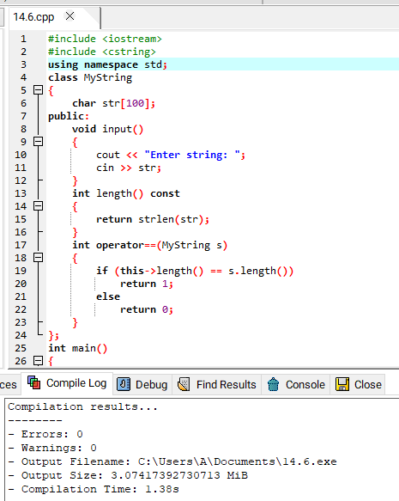

Execution:
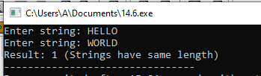

Overloading Arithmetic Assignment Operators
The arithmetic assignment operators are used to increase the value of a variable. Suppose a and b are two integers and the following statement is executed:
a += b;

The above statement will add the values of a and b and assign the result to a. The arithmetic assignment operator += cannot work with user-defined objects. But it can be overloaded in order to use it with user-defined objects.
Program 14.7
Write a program that overloads arithmetic assignment operator to work with user- defined objects.
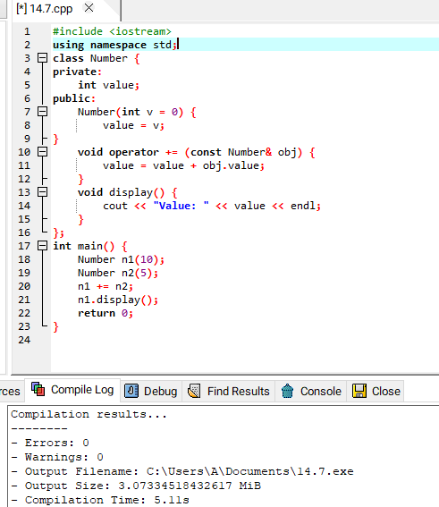

Execution:
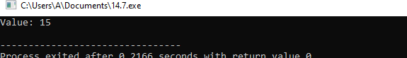

INHERITANCE

A programming technique that is used to reuse an existing class to built a new class is known as inheritance. The new class inherits all the behavior of the original class. The existing class that is reused to create a new class is known as super class, base class or parent class. The new class that inherits the properties and

functions of an existing class is known as sub class, derived class or child class. The inherence relationship between the classes of a program is called a hierarchy.
Example:
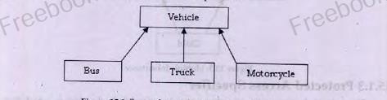

Advantages of Inheritance
Some important advantages of inheritance are as follows:
- Reusability
- Saves time and effort
- Increase program structure and reliability

Categories of inheritance
There are two categories of inheritance :
    - Single inheritance
    - Multiple inheritance

Protected Access Specifier
The private data member of a class are only accessible in the class in which they are declared. The public data members are accessible from anywhere in the program. The protected access specifier is different from private and public access specifier. It is specially used in inheritance.it allows a protected data member to be accessed from all derived classes but not from anywhere else in the program. It means that child class can be access all protected data members of its parent class.
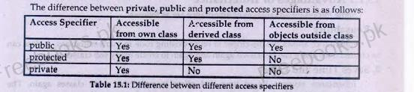

Specifying a derived class
The process of specifying a derived class is same as specifying simple class. Additionally, the reference of parent is specified along with derived class name to inherit the capabilities of parent class.
Syntax:
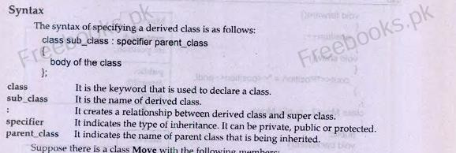

Example:
#include <iostream.h> #include <conio.h> class Move
{
Protected: int position; public: Move()
{
postion =0;
}
void forward()
{

position++;
}
void show()
{
cout<<“Position = “<<position<<endl;
}
};
class Move2 : public Move
{
public:
void backward ()
{
position--;
}
};
void main()
{
Move2 m; m.show();
m.forward():
m.show();
m.backward();
m.show();

getch();
}

Accessing Members of Parent Class
An important issue in inheritance is the accessibility of base class members by the objects of derived class. It is known as accessibility. The objects of derived class can access certain members of parent class.

Accessing Constructors of Parent Class
The objects of derived class can access certain constructors of parent class. It will use an appropriate constructor from parent class if no constructor is declared in derived class. The program in previous example declares an object m of derived class. There is no constructor in the derived class. The complier automatically uses the constructor of parent class.
Syntax:
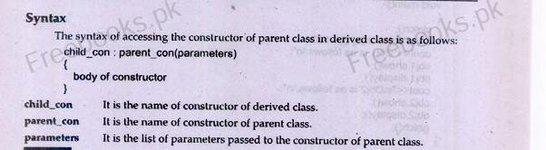

Example:
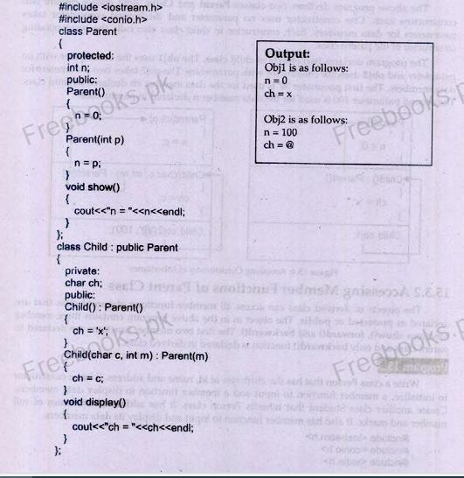

Accessing Member Functions of Parenting Class:
The object of derived class can access all member functions of the parent class that are declared as protected or public. The object m in the previous program contains three member functions show (), forward (),and forward(). The first two member functions are declared in parent class and only backward() functions is declared in derived class.
Example:
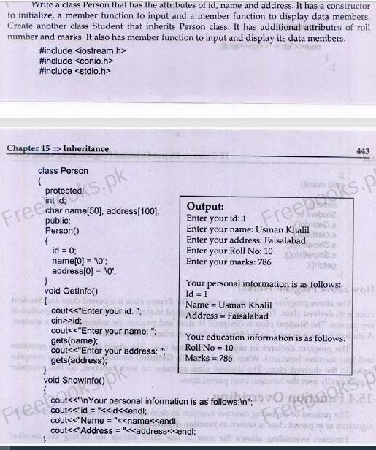

Function Overriding
The process of declaring member function is derived class with the same name and same signature as in parent class is known as function overriding. Function overriding allows the user to use same names for calling the member functions of different class. When a member function is overridden in the derived class, the object of derived class cannot access the function of parent class. However, the function of parent class can be accessed by using scope resolution operator.
Program 15.3
Write a base class computer that contains data members of wordSize (in bits), memorySize (in megabytes), storageSize (in megabytes), and speed (in megahertz). Derive a laptop class that is kind of computer but also specifies the

object’s length, width, height and weight. Member functions for both classes should include a default constructor, a constructor to initializes all components and a function to display data member.
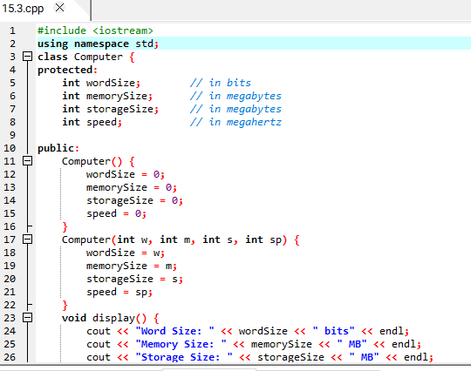
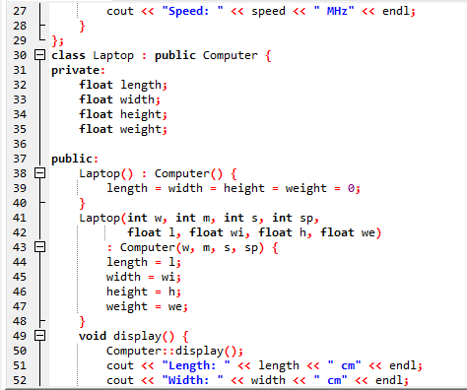
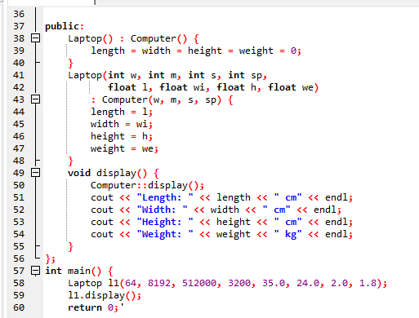

Execution:
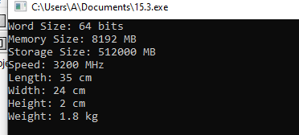

Types of Inheritance
A parent class can be inherited using public, protected or private type of inheritance. The type of inheritance defines the access status of parent class member in the derived class.

Public Inheritance
In public inheritance, the access status of parent class member in the derived class remains the same. The public members of parent class become public members of derived class. The protected members of parent class become protected members of derived class. The private members of parent class become private members of derived class.
Syntax:
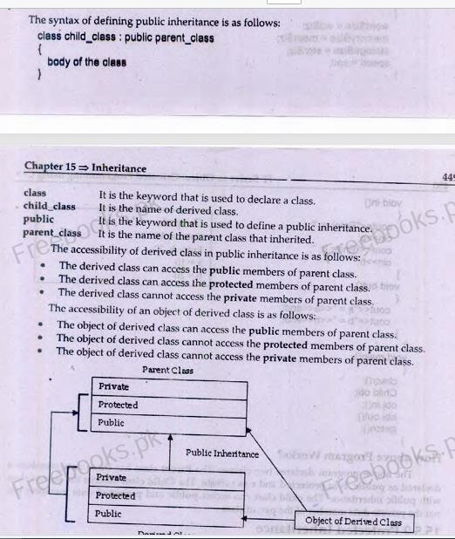

Program 15.4
Write a program that declares two classes and defines a relationship between them using public inheritance.

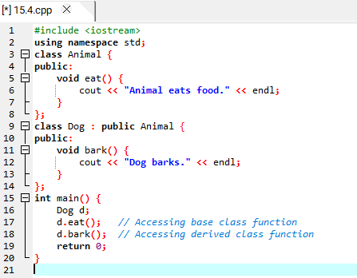

Execution:
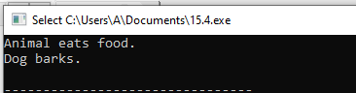

Protected Inheritance:
In protected inheritance, the access status of parent class members in the derived class is restricted. The public members of parent class become protected members of the derived class. The protected members of parent class become protected members of the derived class. The private members of parent class become private members of the derived class.
Syntax:
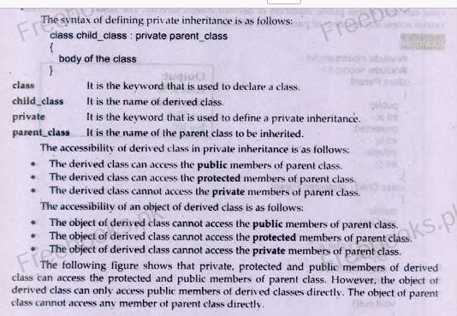

Private Inheritance:
In private inheritance, the access status of parent class members in the derived class is restricted. The private, protected and public members of parent class all become the private member of derived class.
Syntax:
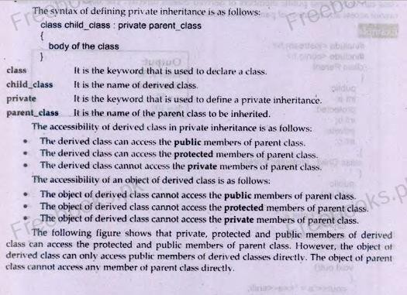
+

Multilevel Inheritance
A type of inheritance in which a class is derived from another derived class is called multilevel inheritance. In multilevel inheritance, the member of parent class are inherited to the child class and the members of child class are inherited to the grand child class. In this way, the member of parent class and child class are combined in grand child class.
Example:
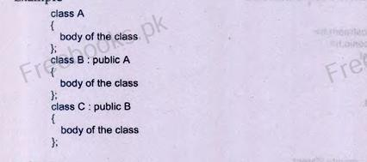

Multilevel Inheritance with Parameters
The member functions in multilevel inheritance can pass the value to the member functions of parent classes. When a function is overridden, the member function in child class calls the member function in the parent class. It can also send parameter values to the parent class functions.
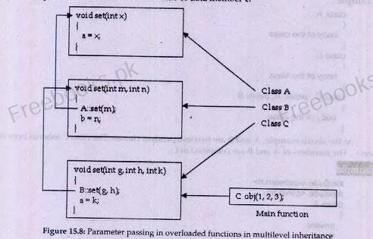

Multiple Inheritance
A type of inheritance in which a derived class inherits multiple base classes is known as multiple inheritance. In multiple inheritance, the derived class combines the members of all base classes.

Class A
Class B
Class C

Containership
A technique in which a class contains an object of another class as its member is called containership. This type of relationship between classes is also called has-a relationship. It means that one class has an object of another class as its member.
Example:
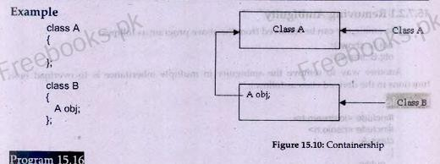

POLYMORPHISM

The word polymorphism is a combination of two words poly and morphism. Poly means many and morphism means form. In object-oriented programming, polymorphism means that an object may behave differently in different conditions. It allows a programmer allow to reuse and extend the code. The same code acts differently depending on the situation.
The user does not have to know the exact type of the object in advance. The behavior of the object can be implemented at run time. It is called late binding or dynamic binding. Polymorphism is implemented by using virtual function.

Pointer to Object
A pointer can also refer to an object of a class. The member of an object can be accessed through pointers by using the symbol ->. The symbol is known as member access operator.

Syntax:
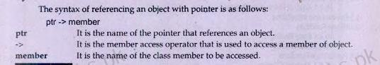

Program 16.1
Write a class with an integer data member, a function to input and a function to display it. Creates an object of the class using pointer and class its member functions.
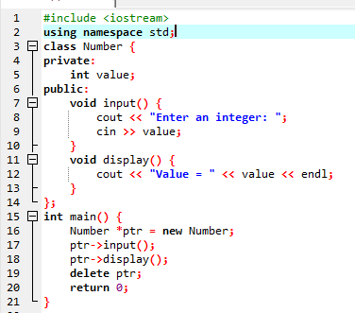

Execution:
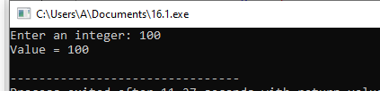

Array of Pointers to Objects
An array can store same data type of data. An array of pointers can store memory addresses of the objects of same class. It allows the user to create a large number of objects in memory using new operator and process them easily using loops. Each element of the array will refer to a different object in the memory.

Program 16.2
Write a class that contains an attribute name, a function to input and a function to display name. Creates array of pointers in which each element refers to an object of the class.
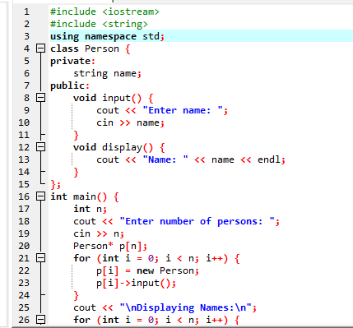

Execution:
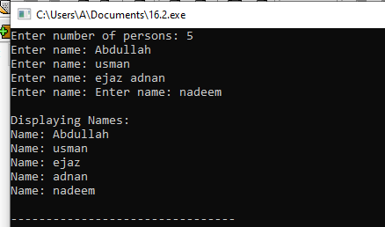

Pointers and Inheritance
Pointers have very important capability of storing the addresses of different objects. A pointer can store the address of object whose type is same as the type of pointer. It can also store the address of any object that belongs to any child class of the pointer’s class. Suppose there are three classes of A, B and C. the class A is a parent class whereas B and C are child classes. A pointer ptr of class A can store the addresses of all objects of A, B and C.

Example:
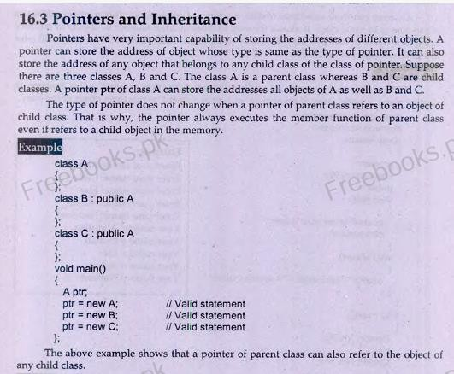

Virtual Functions:
Virtual means existing in effect but not in reality. A type of function that appears to exist in some part of a program but does not exist really is called virtual function. Virtual functions are used to implement polymorphism. They enable the user to execute completely different functions by the same function call.
Example:
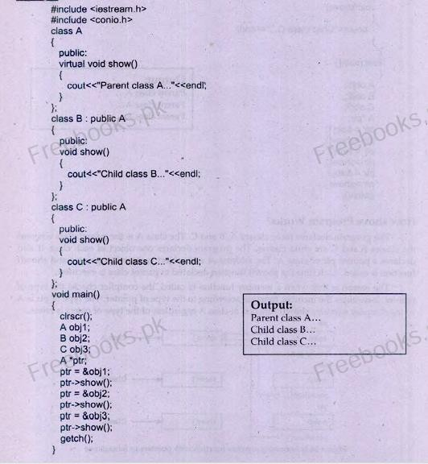

Early binding
The assignment of types to variables and expressions at compilation time is known as early binding.

Late binding
The assignment of types to variables and expressions at execution time is known as late binding.

Pure Virtual Functions
A type of virtual function that has no body is known as pure virtual function. Afunction can be declared as pure virtual function by adding two things:
- The keyword virtual at the start of the function declarator
- The = 0 at the end of function declarator
The pure virtual functions are used in the classes which are not used directly. The user can inherit the class and then override the pure virtual function in the child class.

Abstract Classes
A type of class that contains any pure virtual function is called abstract class. An- abstract class cannot be used directly. It means that no object of an abstract class can be created. However, a child class can inherit an abstract class and use it by overriding its pure virtual function.
The abstract classes are used to create a model class. Any user who creates a new class by inheriting an abstract class has to override the pure virtual functions. The child class also becomes an abstract class if any of the pure virtual functions is not overridden in child class.
Syntax:
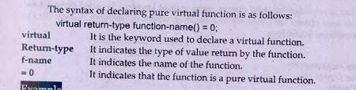

Virtual Base Class
A class that is inherited by child classes using virtual keyword is called virtual base class. The virtual base classes are necessary in a situation where the member of base class is duplicated in multilevel inheritance.
Example:
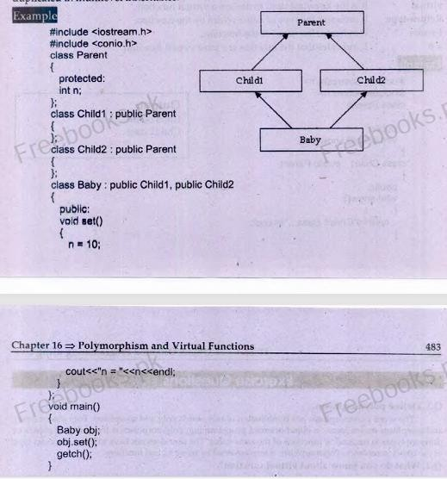

FILE HANDLING

Files
A File is a collection of related records. A record contains data about an entity. A file can be used to save any type of data. Files are stored on secondary storage. The data is stored in files permanently.
Normally, 4 program inputs data from user and stores it in variables. The data stored in the variables is temporary. When the program ends, all data stored in variables is also destroyed. The user has to input data again from keyboard when the program is executed next time. The data has to be entered each time program is executed that wastes time. The user may also type wrong data at different times.
A data file can be used to provide input to a program. It can also be used to store the output of a program permanently. If a program gets input from a file instead of

keyboard, it will get the same data each time it is executed. There will be far less chance of errors.

Advantages of files
Some important advantages of files are as follows:
- Files can store large amount of data permanently.
- Files can be updated easily.
- One file can be used by many program for same input.
- Files save time and effort to input data via keyboard.

Types of Files
- Text Files
- Binary Files

File Access Methods
- Sequential Access Method
Sequential access method is used to access data in the same sequence in which it is stored in a file. This method reads and writes data in a sequence. In order to read the last record, it has to read all records stored before the last one.
Sequential access files are the simplest way of organizing a file. In sequential access files, the contents are written one after the other. The length of each record is not fixed. It means that each record occupies different amount of memory.
The advantage of this method is that the memory is not wasted. The disadvantage that it take more time to search a record. For example, if the user needs to find the third record, he has to read the first two records also. It is not possible to directly jump to the third record. The reason is that the record length is not fixed. It is not possible to determine the position of the required record in the file. Word processing program usually store files in a sequential format. Similarly, the audio tapes are accessed sequentially.
- Random Access Method
Random access method is used to access any data item directly without accessing the preceding data. This method does not read or write data in sequence. It is very fast access method as compared to sequential access method. A searching

operation with random access method takes far less time to find a data item. Random access files store data in fixed length records. The main disadvantage of this method is that fixed size of the record is used even if the user wants to store a small sized record. It wastes memory space. Suppose a record of 10 bytes is used to store a complete sentence in a file. If a sentence consists of only single letter like 'a', it will occupy 10 bytes to store this letter. However, this method speeds up access time because the position of each record can be determined easily as each record takes fixed length. For example, If a record length is fixed as 10 bytes, the file record will start at byte number 50. It is easier to jump directly to that location instead of reading the first four records before accessing, the filth
Database management systems store files in a random access format. Similarly, audio, CDs are accessed randomly.

Stream
A stream is a series of bytes associated with a file. It consists of data that is transferred from on location to another. Each stream is associated with a specific file by using the open operation. The information can be exchanged between a file and the program once a file is opened. This exchange is performed with the help of streams.

Types of stream
There are two main types of streams i.e. input stream and output stream. The streams are automatically established when a program starts execution. The user can use them to input and output data at any time.
Following are two main streams in C++ language:
- Standard input stream
- Standard output stream

The End

